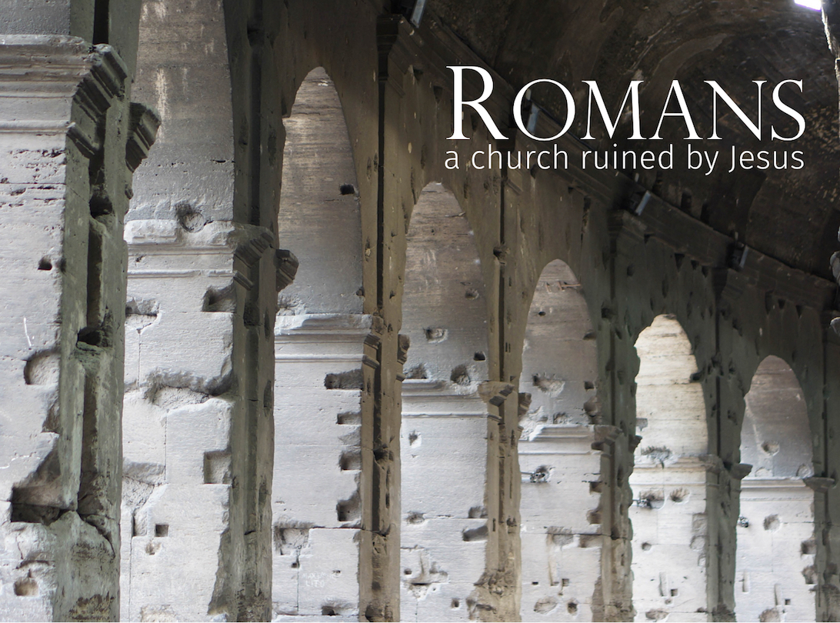
For we are… God's building… like living stones being built into a house.” (1 Corinthians 3:9; 1Peter 1.5)

LifeGroup
resource guide
for the week of October 9
Followers of Jesus Christ do not go to church. Followers of Jesus Christ are the Church. God’s building is no longer the temple or a house; it is a people called and set apart by Him. God’s building is not a holy place; God’s building is a holy people… and God’s building is not complete, it is still under construction— but one day it will comprise all peoples, tribes, and tongues.
Remember, to the untrained eye, most buildings under construction look like a terrible mess until the last stage is reached. The same is true with the Church. The dust and dirt, chaos and confusion, may make it hard to believe that this could really be the temple of God. Yet, if we have faith and patience, we will see that the Architect and Builder is hard at work, and knows very well what He is doing— He is building us into “God’s building.” The apostle Peter observed, "You also, like living stones, are being built into a spiritual house.” This has two immediate consequences for every follower of Jesus Christ,
First, the Church is made up of "living stones” not cold, inanimate ones. The building God is constructing is alive to Christ and responsive to its call. It is not ostentatious nor pretentious. It is not constructed for the privileged few or other "bricks” just like us. The bricks are not fixed or inflexible. The building of the Lord is a multipurpose structure designed to be living reference point for the arrival of God’s kingdom. While this analogy may be an architectural impossibility, it reflects God’s design for His Church today. He is building one Church— united, interdependent, and alive— whose impact upon the world shall be contingent upon the stones’ willingness to be built together by the Lord into the house of His choosing.
Second, individual Christians are not the "building,” we are the brick! Individual followers of Jesus Christ may not echo the proclamation of Henry David Thoreau, “I am my own church.” Time and again Scripture exhorts us not to neglect meeting together, as is the habit of some…” (Hebrews 10.25). Nothing guts the momentum of any Christian fellowship faster then sporadic participation and attendance. How will the bricks be built together if they remain scattered and distant? Scripture is very clear: God expects our faith to be lived out in community. He intends us to be contributors not merely consumers— to do otherwise is to deprive and weaken God’s house. He desires us to be a vital part of something that is much greater than we can ever imagine or implement alone.
The foundation and cornerstone of God’s house is Jesus Christ. His personal oversight insures that the house will be radiant, responsive, and resilient. It is His life which sustains the whole and gives shape to what is built. "In him the whole building is joined together and rises to become a holy temple in the Lord.” (Ephesians 2:21) Does your commitment to Jesus Christ reflect His high priority and design for the Church? Does your lifestyle reflect a priority for worship and participation in your local congrega­tion? Men and women of God, don’t deprive the Church-- your LifeGroup and the larger FCC community-- of the gifts God has given you. We cannot bless and influence lives without YOU!
Enjoy your LifeGroup,
Mark

Getting to know one another better…
Imagine you have been exiled to a desert island. You can take 3 things with you besides life essentials. You can take 1 book; 1 recorded song; and one luxury item. What would these 3 items be and why?

Luke 8.1-3
Luke 8:1 Soon afterward Jesus began a tour of the nearby towns and villages, preaching and announcing the Good News about the Kingdom of God. He took his twelve disciples with him, 2 along with some women who had been cured of evil spirits and diseases. Among them were Mary Magdalene, from whom he had cast out seven demons; 3 Joanna, the wife of Chuza, Herod’s business manager; Susanna; and many others who were contributing from their own resources to support Jesus and his disciples. (The New Living Translation)

Commentary
In this little paragraph Luke introduces the next section of his narrative about Jesus. Luke highlights Jesus' activities as He tours the nearby towns and villages preaching and announcing the Good News about the Kingdom of God. The New Living Translation appropriately "spells out" two words usually translated simply as "preaching and teaching" or "proclaiming and announcing". The first word, preaching, describes the activity. The second word, announcing, describes the content of the preaching. This second word is a Greek word that actually contains the Greek word for "good news". The content of Jesus' preaching/teaching was the good news about the Kingdom of God. Then follows a list of diverse relationships who had been blessed and welcomed into this Kingdom advance. This list of men and women transcends the cultural norm that would have separated women from men.

This introduction highlights, in an almost matter-of-fact manner, 3 significant aspects to Jesus' ministry. First, the center point of Jesus' ministry is the Kingdom of God. This Kingdom must be announced, defined, and described -- hence the parables that will follow throughout Luke's gospel. Second, we see the significance of relationships-- Jesus does not travel alone. His is a kingdom community that includes men AND women at the center with Him. Jesus creates community among women and men who were formerly strangers. Finally, while the Kingdom must be announced, defined, and described, it is more than words. The Kingdom must be expressed in a way that blesses and liberates lives. So we see a list of women who had been cured of evil spirits and diseases that span a wide social spectrum.

Finally, it remains for us to briefly answer the question: why is Jesus' teaching about the Kingdom of God Good News? Jesus words are Good News about the Kingdom of God because Jesus is announcing that the Kingdom of God is here. What Israel longed for (see Isaiah 44. Especially 44.1-6; 24-28 or Isaiah 52.6-7) is happening now! God is really present now! God is redemptively active now! God is exercising his rule now! God's realm is being established in Israel now!

Jesus heralds the dawning of a new day. This new day is starting off small -- almost imperceptible-- but do not let its size fool you (Luke 13.19). Whether you can see it or not the world has changed because the Kingdom of God is present. This is why the announcement of this Good News requires both words and deeds. It is proclamation and expression which prevent the Kingdom’s small start from continuing unnoticed.

Reflecting on Luke 8.1-3…
When you hear the phrase, "the Kingdom of God" what comes to mind for you?

Jesus announces that God's Kingdom is here now (see Mark 1.15). How do you see God's Kingdom present in your midst today?

Why do you think God's Kingdom must begin "small" when God is more than capable of doing something “big"?

On Sunday, October 2, Mark introduced the new mission statement for Faith Community:
to express and present God’s presence
so we might bless and influence
generations and cultures toward Jesus Christ.

Mark shared that he used "God's presence" instead of "God's Kingdom" because he was aware that many people might not understand what "God's Kingdom" meant. In light of the commentary above, what do you think it means to express and present

• God's real presence?

• God's redemptive activity?

• God's rule?

• God's realm?

Why do you think that Mark chose to place "express" before "present" in the our new mission statement?

What do you think it means for Faith Community to "bless and influence generations toward Jesus Christ”?

What are ways that your LifeGroup can live out this vision?

My prayer requests (write in advance what you want your group to pray for…)

Praying for my group…

