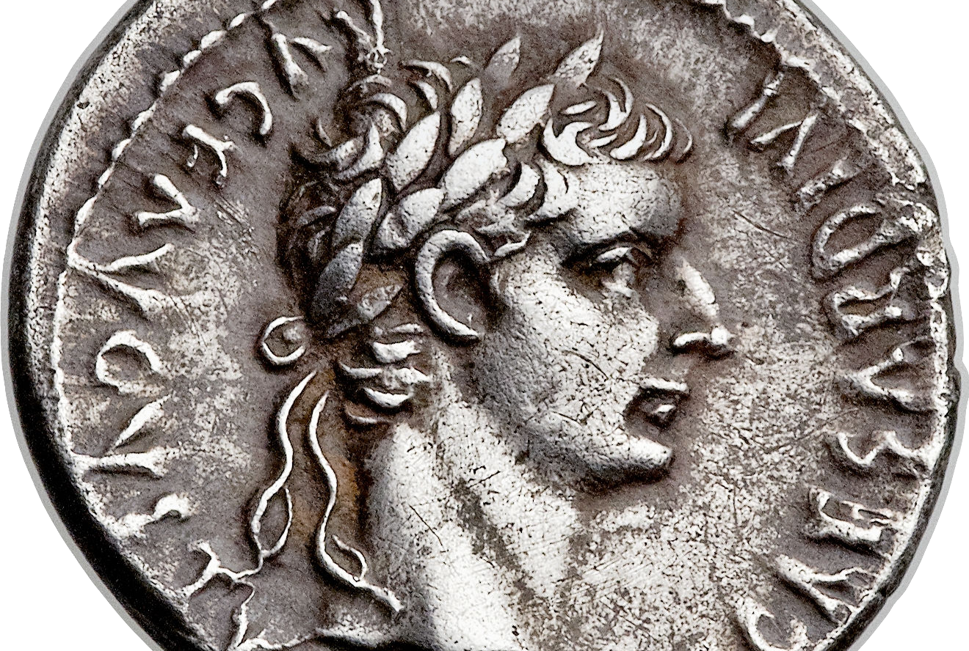
weekend
resource guide
for the week of 8 October

Matthew 5-7: When Jesus saw the crowds He went up on a mountainside and sat down. His disciples came to Him and He began to teach them saying, “Blessed are the poor in spirit... Blessed are those who mourn... Blessed are the meek... Blessed are those who hunger and thirst after righteousness... Blessed are the merciful... Blessed are the pure in heart for they will see God... Blessed are the peacemakers... Blessed are those who are persecuted because of righteousness... Blessed are you when people insult you, persecute you, and falsely say all kinds of evil against you... You are the salt of the earth... You are the light of the world... You have heard it said, “Do not murder... Do not commit adultery... When you pray do not be like the hypocrites... Do not worry... The man who hears my words and does not do them...”

The Sermon on the Mount contrasts two ways of living before God. One way measures faithfulness by what we do and the other by who we are. In short, the Sermon on the Mount is about integrity that is distinctly Christian. Every sentence bears the conviction that who we are on the inside matters immensely to Jesus because there is no inherent relationship between what we do and who we truly are. A man may go to church, sing the songs, and read his Bible but never have the essential poverty of spirit that God blesses with salvation, love, and strength (Matthew 5.3). A man may not cheat on his girlfriend or wife but his fidelity is compromised by his obsession with lust and sexual fantasies of every kind (Matthew 5.27-30). A man may pray eloquently in front of others but God knows that it is not an expression of faith but a will to impress, influence, and manipulate (Matthew 6.5-15). Integrity is not who you are when no one is looking. This understanding confuses privacy with honor.

Christian integrity is distinct. Philosophers suggest that integrity means living life according to a consistent set of principles— but surely consistency is the wrong criterion because one could then advocate that Hitler had integrity! Christian integrity is less a state and more an exercise of living, discerning, loving, reflecting, and doing that is inspired, empowered, and exemplified by the person and power of Jesus.

There are three basic steps to pursuing a life of Christian integrity. The first step is to spend the time to discern the presence of Jesus in our life. Our relationship with Him is our foundation for understanding right and wrong; good and evil; commitment and hypocrisy. Therefore, prayer, Bible-study, and quiet reflection are essential disciplines for those seeking a life of integrity. Christian integrity is distinct because we live according to our relationship with Jesus— He alone is our living “set of principles” that we seek to be consistent with.

The second step to a life of Christian integrity is to struggle to live according to our relationship or faith in Jesus Christ. Salvation is a free gift but the Christian life is a lifetime-encompassing challenge. We pursue a life of integrity when we are willing to fight, strive, and persevere to live in a manner that reflects the life of Jesus Christ within us. This means that a life of Christian integrity will be counter-intuitive. We will love those who Jesus loves although we may initially feel no natural attraction; we will take actions that will advance Christ but do little for us; we will risk the loss of favor and esteem to live out our life in Christ.

The third, and overlooked, step to a life of Christian integrity requires us to be open and emphatic about Who and what we are living by— to say why we do the things we are doing or believe the things we are believing. Witness is an essential ingredient to Christian integrity because integrity, as a lifestyle, can never be separated from the person and power of Jesus Christ. We live, believe, act, relate, love, hope, judge, and yearn the way we do because of Jesus. Christian integrity mandates that we bear witness to Him because it is only His person that can make sense of the life of integrity that we struggle to achieve.

I believe that history is nothing more than the record of all collisions between character and circumstance.

Enjoy your LifeGroup!

Getting to know one another better…
October is the season of “trick or treat.” What is your favorite memory of this season growing up?

Mark 12.1-17: The Vineyard and the Coin…
He began to speak to them in parables. “A man planted a vineyard, put a hedge around it, dug a wine press, and built a tower. Then he leased it to tenant farmers and left on a journey. 2 At the proper time he sent a servant to the tenants to obtain from them some of the produce of the vineyard. 3 But they seized him, beat him, and sent him away empty-handed. 4 Again he sent them another servant. And that one they beat over the head and treated shamefully. 5 He sent yet another whom they killed. So, too, many others; some they beat, others they killed. 6 He had one other to send, a beloved son. He sent him to them last of all, thinking, ‘They will respect my son.’ 7 But those tenants said to one another, ‘This is the heir. Come, let us kill him, and the inheritance will be ours.’ 8 So they seized him and killed him, and threw him out of the vineyard. 9 What [then] will the owner of the vineyard do? He will come, put the tenants to death, and give the vineyard to others.

10 Have you not read this scripture passage:
‘The stone that the builders rejected
has become the cornerstone;
11 by the Lord has this been done,
and it is wonderful in our eyes’?”

12 They were seeking to arrest him, but they feared the crowd, for they realized that he had addressed the parable to them. So they left him and went away.

13 They sent some Pharisees and Herodians to him to ensnare him in his speech. 14 They came and said to him, “Teacher, we know that you are a truthful man and that you are not concerned with anyone’s opinion. You do not regard a person’s status but teach the way of God in accordance with the truth. Is it lawful to pay the census tax to Caesar or not? Should we pay or should we not pay?” 15 Knowing their hypocrisy he said to them, “Why are you testing me? Bring me a denarius to look at.” 16 They brought one to him and he said to them, “Whose image and inscription is this?” They replied to him, “Caesar’s.” 17 So Jesus said to them, “Repay to Caesar what belongs to Caesar and to God what belongs to God.” They were utterly amazed at him.

What? (does the Bible say)
We are studying the Gospel of Mark in reverse in hopes of intentionally gleaning new insights that come through the benefit of hindsight. In Jesus’ day, people also listened to His message through the benefit of hindsight. The parable of of the wicked vineyard tenants expects the people to remember through hindsight the prophetic warnings of Isaiah 5.1-7.

Read Isaiah 5.1-7. What are some of the similarities and differences between Jesus’ vineyard parable and Isaiah’s vineyard prophecy?

If the tenants are Israel and its religious leaders, who are “the owner”, “the servants”, “the son” and “the others?”

What is the “inheritance” and why do you think they want it?

The Herodians were a puppet government that supported the rule of Rome. The Pharisees were ardent nationalists who thought Torah reform would transform the nation. Normally they were enemies but this day finds them united. What were their motives?

What arguments did they use to try to trap Jesus? What was the trap meant to expose?

Now what? (should/will I think based on what this passage says)
Why would Jesus tell a parable that was sure to provoke the religious leaders?

Who do you think are the “Herodians” and “Pharisees” God wants to speak to today?

So what? (difference will this passage make in how I live)
We tend to think that the Gospel is simply telling people: “Jesus died for you.” If that was true, then the content of the 4 Gospels would be very different.

Both of these narratives appear in Matthew and Luke (Matthew 21:33-46; 22:15-33 and Luke 20:9-39). What is the message of the Good News you think these 2 stories preach? (Hint: if your answer is irrelevant than it is NOT the answer!) How can your answer be part of your faith testimony/expression today?

What response do you think these narratives are meant to provoke in us? What do you think God wants you to change or to do as a response to these 2 narratives? What difference does He want the Vineyard and the Coin to make in you?

What do you think Jesus is expecting you to do when he says “pay back Caesar what is Caesar’s?” What is He expecting you to “pay” when He says, “pay back God what is God’s?”

Do you think you are actively paying God what is God’s? Why or why not?

There is a tragedy in these narratives. The very servants who thought they were preserving Israel politically and spiritually were actually hostile to the God of Israel. What steps can you/your LifeGroup take to ensure that this does not happen to you?

These two “stories” raise the bar on how we regard and worship Jesus. The Vineyard warns us that He is Judge and the Coin declares He is Lord. What do you find it difficult to surrender and submit to Him? How can your LifeGroup encourage your surrender and submission?

My prayer requests (write in advance what you want your group to pray for…)

Praying for my group…

