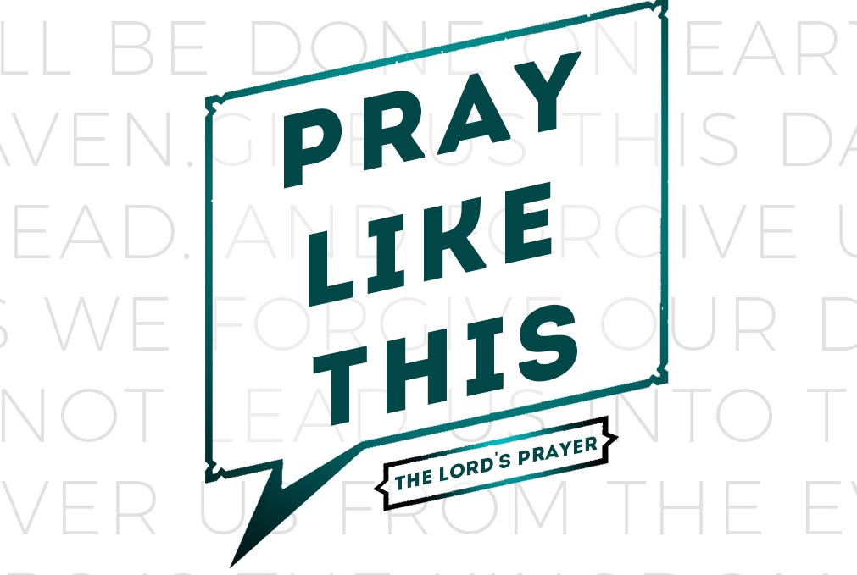
weekend
resource guide
for the week of 10 March

Now Jericho was tightly shut.. The LORD said to Joshua, “See, I have given Jericho into your hand... You shall march around the city, all men of war circling the city once. You shall do so for six days. Also seven priests shall carry seven trumpets before the ark; then on the seventh day you shall march around the city seven times, and the priests shall blow the trumpets.... When you hear the sound of the trumpet all the people shall shout with a great shout; and the wall of the city will fall down flat. (Joshua 6.1-5)

RECAP: Intimidation is a powerful and unique fear... Intimidation is powerful because it alone can cause a man to sacrifice the opportunities of tomorrow for the status quo of yesterday. Intimidation browbeats a man into deep feelings of inadequacy as his creativity, vision, and might wilt before it. Intimidation is unique because it is a fear that threatens our willingness to embrace God’s future for our lives. All intimidation has to do is recite reality because it wants to disqualify you because you are not perfect... Intimidation goes so far as to use our heroes against us by reminding us that we can never be as good as those we highly esteem/idolize!
God showed Joshua three strategic tactics for overcoming obstacles and intimidation. Last week we examined the first one (Walk around it... don’t talk about it). This week we’ll look at the other two...

Sound your trumpet... don’t beat your drum. In the Hebrew and Greek languages there is only one word for wind, breath, and spirit because the Biblical worldview depicts a recognition that our daily breath (our lives) requires God’s breath (Holy Spirit) to be abundant, fruitful, and victorious. Therefore I do not think God’s instrumental preference is capricious or insignificant.

Whoever heard of an army who marched to the beat of trumpets as they went to battle?! Armies march to the beat of drums. Their beat establishes the pace of pursuit and their volume reflects the might of men. Trumpets on the other hand are wind instruments. Their primary role in Israel was to call people to praise not to war. The message is clear: Spirit not sweat is the secret to overcoming intimidation and obstacles. Loved ones, there is nothing like Holy Spirit-empowered praise in the face of intimidation and obstacles to focus our eyes on the One who holds everlasting victory in His hands.7

Shout... don’t mumble or whisper. The Lord told Joshua in no uncertain terms, “When you hear the sound of the trumpet all the people shall shout with a great shout; and the wall of the city will fall down flat.”
There is nothing vague or ambiguous here. God is not joking or playing juvenile games. He is not trying to concoct some kind of manly emotionalism. He is not asking for a vain display of triumphalism. He is calling them to shout on cue and in one accord so that Jericho might be soundly defeated. Three questions immediately come to mind.

1. Why should we shout? Because there are real walls that evil has intentionally built against us and there are invisible walls that sin has subtly fabricated within us. Both must come down. They will not come down through indifference or pious whisperings. God declares that there are some things that will only fall before the shout of His people.

2. What should we shout? A quick study of “shouting” in the Bible seems to indicate that we are to shout His praises, shout His triumphs, and shout His graciousness that stands ready to bless. All three of these usually stand in marked contrast to the pretenses, bluffs, and power of the obstacles and intimidation we face.

3. Do I really have to shout? Yes! There is a season for silence (see last week!) and a season to shout. Our culture promotes the misguided notion that any display of spiritual emotion is foolish, fanatical, and freakish. Thus we have adopted words like “reverent,” “decorum,” and “propriety” to justify our silence before a God who still recognizes the value of a good shout! The challenge is to be willing to shout yet wise enough to wait for God’s moment to do so.

There are Jerichos everywhere. Fortified cities of doubt, fear, pride, strife, division, despair, hatred, poverty, and prejudice. They exist within us and around us. Let us learn to apply God’s Jericho strategy as we overcome our cultural apprehensions so that we may breach our adversary’s walls. Now that will be something to shout about!

Enjoy your LifeGroup!

What is your earliest memory regarding, “forgiveness”?
Getting to know one another…
Reading Scripture together…

Matthew 6.12, 14-15; 18.21-35: The forgiveness we need to give...
and forgive us our debts,
as we also have forgiven our debtors.
14 For if you forgive others their trespasses, your heavenly Father will also forgive you, 15 but if you do not forgive others their trespasses, neither will your Father forgive your trespasses.
18:21 Then Peter came and said to Him, “Lord, how often shall my brother sin against me and I forgive him? Up to seven times?” 22 Jesus *said to him, “I do not say to you, up to seven times, but up to seventy times seven.
18:23 “For this reason the kingdom of heaven may be compared to a king who wished to settle accounts with his slaves. 24 “When he had begun to settle them, one who owed him ten thousand talents was brought to him. 25 “But since he did not have the means to repay, his lord commanded him to be sold, along with his wife and children and all that he had, and repayment to be made. 26 “So the slave fell to the ground and prostrated himself before him, saying, ‘Have patience with me and I will repay you everything.’ 27 “And the lord of that slave felt compassion and released him and forgave him the debt. 28 “But that slave went out and found one of his fellow slaves who owed him a hundred denarii; and he seized him and began to choke him, saying, ‘Pay back what you owe.’ 29 “So his fellow slave fell to the ground and began to plead with him, saying, ‘Have patience with me and I will repay you.’ 30 “But he was unwilling and went and threw him in prison until he should pay back what was owed. 31 “So when his fellow slaves saw what had happened, they were deeply grieved and came and reported to their lord all that had happened. 32 “Then summoning him, his lord *said to him, ‘You wicked slave, I forgave you all that debt because you pleaded with me. 33 ‘Should you not also have had mercy on your fellow slave, in the same way that I had mercy on you?’ 34 “And his lord, moved with anger, handed him over to the torturers until he should repay all that was owed him. 35 “My heavenly Father will also do the same to you, if each of you does not forgive his brother from your heart.”
What? (does the Bible say?)

NOTE: The religious leaders of Jesus' day taught that three times was the limit on forgiveness. Peter thought he was being gracious to extend it to seven times.

What does Jesus’ answer, “seventy-seven times”, mean?

What does Jesus' answer tell you about how forgiveness operates in his kingdom?

Who watched with dismay as the first slave refused to have mercy on the second? What do you think makes them want to report this behavior to the King?

What does verse 35 mean? Does God forgive us only on the condition that we forgive others?

What IS forgiveness and how does one know when he/she has genuinely forgiven someone?
So what? (what difference does it make?)

Is it always necessary to tell the person(s) in question that you have forgiven them? Why or why not?

Does forgiveness mean that the relationship must return to whatever normal was before the offense? Why or why not?

The parable is obviously not about how to treat people who owe you money. What do the two debts represent in our lives? What contrast does Jesus want us to draw?

What debt(s) has God forgiven you?

How does this compare to the debts owed you?

If God is so willing to forgive us, why are we sometimes unwilling to forgive others?

Does Jesus' command to forgive without limits mean that we are not to hold others accountable for what they do? Explain your answer.

Now what? (how will I think?)

What person(s) do you need to release from their debts to you?

How will you let Christ work in your life so that you can forgive those who have betrayed, offended, and/or hurt you?

What will this look like?

Is it possible for us to forget the wrongs others have done to us? Do we need to in order to truly forgive someone?

How can you demonstrate God's mercy in a practical way to someone who has wronged you?

Sometimes the person we struggle to forgive is no longer in our lives or has died. If you or someone you know is facing that kind of unresolved situation, what specific things can you do that might bring a greater sense of peace?

How can we encourage the release of authentic forgiveness as a LifeGroup?

Praying for my group…
Prayer requests…
(write in advance what you want your group to pray for…)

