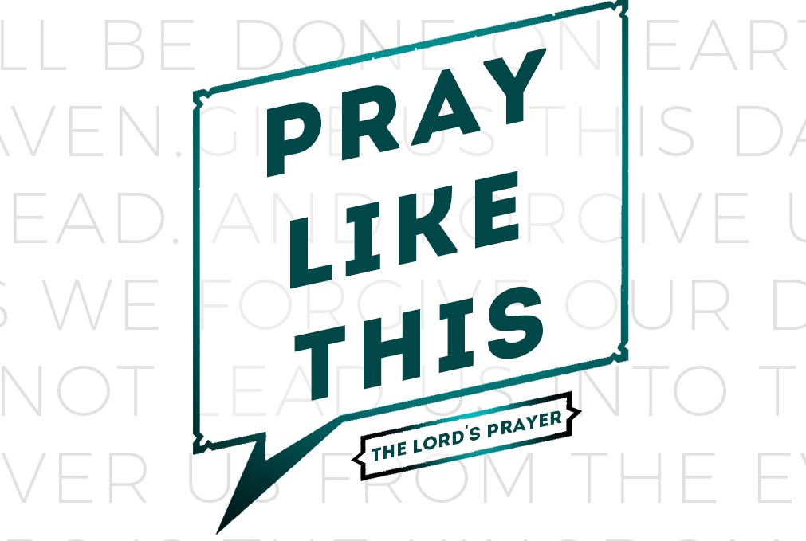
resource guide
for the week of 24 March

weekend

Romans 8.31-35: If God is for us, who is against us?… Who will bring any charge against God’s elect?… Who will separate us from the love of Christ?

Here’s a Christian syllogism…
- A Christian is one who has the omnipotent God in charge of his life.
- No assault can overpower God and there is no force that can compel Him.
- Therefore a Christian can stop worrying about how to fight his daily battles because there is no one who can overpower God.

Nothing can penetrate the “front lines” of a Christian’s life unless God allows it to happen. An attack against a Christian is not merely an attack against a man but against the presence of God who fills the believer’s life.

Has God’s power grown weaker today or are our enemies stronger? Has progress given sin, death, and the devil the leading edge? Certainly not! Brethren, never confuse sin’s bravado for power. While evil may daunt and intimidate men it is nothing but arrogant bluster before our Almighty God. The constant demonstrations of God’s power on behalf of His saints stand in sharp relief to the impotent aid that Satan’s counterfeits offer as an alternative.

Man and Woman of God, strengthen yourself in the knowledge that God’s strong arm reaches down to you in love. With the same faith that persuades you that God exists, creates, and saves, believe this too: His almighty power is your sure friend. You can put it to the test in the following circumstances…

When you are weighed down by sin. You can be certain that no sin is powerful enough to overpower God or to nullify His saving work in Jesus Christ. God, like any king, has always had the power to pardon anything He chooses to. But our confidence does not rest upon His divine whim. The gospel declares that God has freely decided, within the counsel of His will, to establish a covenant to pardon. God has determined to drown your sins in His mercy, spend all He has, and spare not His own rather than let it be said that His steadfast goodness can be overcome by our evil. When sin and Satan terrorize your soul you can confidently contend, “If God is for me, who can prevail against God? Has He ever broken a promise?”

When you are overpowered by temptation. Our Father watches us carefully while we are in the valley of distress and conflict. Your cries bring Him running although, in fact, He has never left you. It is the Lord and not a man who has declared, “Sin will have no dominion over you.” While we may be weak and frail our strength lies in the rock of God’s faithfulness. All the Christian need do is to take shelter within its shade. However, what good will the shade of a mighty rock do us if we deliberately venture forth into the heat of temptation? Why should we be surprised when our faith grows so weak that we stumble and fall into sin?

When you are overwhelmed by work and circumstances. God knows the limits of your strength because His watchful eye is always upon you. When temptation causes you to stagger He will pick you up, burden and all, and carry you to your God-appointed destination. Your first line of defense is not to wrestle—it is to nestle in His promise “I am faithful. I will not let you be tested beyond your strength. I will provide the way out so that you may be able to endure it.” (1Corinthians 10.13)

God is resolved to allow the weakest among us to move Him to action by the mere whisper (whimper?) of His name. The very sight of you in prayer will move His heart to mercy and carry a strong argument for His aid on your behalf.

Enjoy your LifeGroup!

What food tempts you the most to overeat? Why?
Getting to know one another…
Reading Scripture together…

Matthew 4.1-11: lead us not…
Matthew 6.13: ‘And do not lead us into temptation, but deliver us from evil.

Matt. 4:1 Then Jesus was led up by the Spirit into the wilderness to be tempted by the devil. 2 And after He had fasted forty days and forty nights, He then became hungry. 3 And the tempter came and said to Him, “If You are the Son of God, command that these stones become bread.” 4 But He answered and said, “It is written, ‘MAN SHALL NOT LIVE ON BREAD ALONE, BUT ON EVERY WORD THAT PROCEEDS OUT OF THE MOUTH OF GOD.’”

Matt. 4:5 Then the devil took Him into the holy city and had Him stand on the pinnacle of the temple,
6 and said to Him, “If You are the Son of God, throw Yourself down; for it is written,
‘HE WILL COMMAND HIS ANGELS CONCERNING YOU’;
and
‘ON their HANDS THEY WILL BEAR YOU UP,
SO THAT YOU WILL NOT STRIKE YOUR FOOT AGAINST A STONE.’”
7 Jesus said to him, “On the other hand, it is written, ‘YOU SHALL NOT PUT THE LORD YOUR GOD TO THE TEST.’”

Matt. 4:8 Again, the devil took Him to a very high mountain and showed Him all the kingdoms of the world and their glory; 9 and he said to Him, “All these things I will give You, if You fall down and worship me.” 10 Then Jesus said to him, “Go, Satan! For it is written, ‘YOU SHALL WORSHIP THE LORD YOUR GOD, AND SERVE HIM ONLY.’” 11 Then the devil left Him; and behold, angels came and began to minister to Him.
What? (does the Bible say?)

What three words does Matthew use to describe Jesus’ adversary in 4.1-11. Why do you think Matthew used 3 different words?
So what? (what difference does it make?)

Temptations are strong appeals to satisfy legitimate desires in wrong circumstances or by wrong means. In order for these temptations to be genuine tests, there must have been something about each one that Jesus would find desirable. What do you think Jesus found appealing about each temptation and why?

What can we discover about Jesus and His authority from his encounter with Satan?

Luke 4.13 notes: “When the devil had finished every temptation, he left Him until an opportune time.” What is the significance of this statement? Can you think of other incidents in the Gospels where the devil is tempting Jesus?

What can we learn about temptation and how to resist it from Jesus' example?

So what? (how will I think?)

How do you reconcile Matthew 4.1 with James 1.13?

Jesus was "led" into the desert by the Spirit specifically to be "tempted by the devil.” Why do you think the Spirit would lead Jesus into such a difficult situation?

Do you think the spiritual being referred to in this passage (the tempter, devil, satan) exists? Why or why not?

Jesus' temptations appear to have little resemblance to ours today. Yet we are told in Hebrews 4.15 that he "has been tempted in every way, just as we are." How can you explain that?

Because Jesus did not give in to the devil, what are the results for us? Check your response with Hebrews 2.14-18 and Hebrews 4.14-16.

Now what? (what difference does it make?)

Do you ever feel that the Lord has led you into a season of testing? Why do you think God did this?What, if any, was the result(s) from these tests you thought of?

How did Jesus and the devil use the Bible differently?

Since the Bible can be misused, how can we learn to use the Bible the right way?

Do you use the Bible to discern God’s will and/or to combat temptation? Why or why not?

In what specific areas of your life is temptation the strongest for you these days?

What steps can you take this week to resist the temptations you are facing now?

How can your LifeGroup encourage and strengthen you to stand firm before the temptations you face?

How might your LifeGroup combat temptation together?

Praying for my group…
Prayer requests…
(write in advance what you want your group to pray for…)

