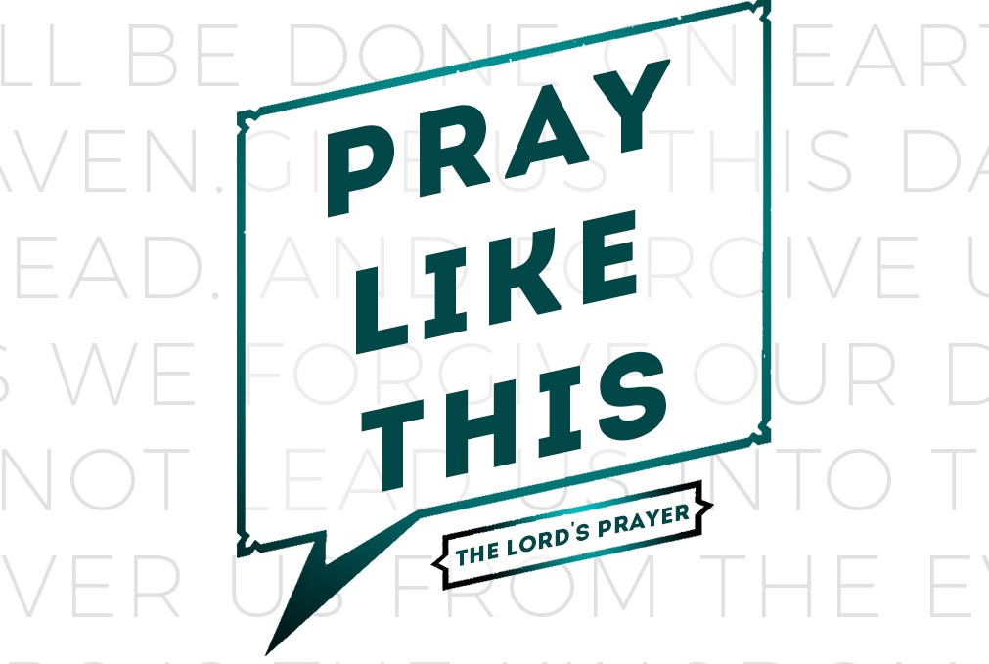
resource guide
for the week of 31 March

weekend

“Put out into the deep water and let down your nets for a catch.” 5 Simon answered and said, “Master, we worked hard all night and caught nothing, but upon Your word I will let down the nets.” 6 When they had done this, they enclosed a great quantity of fish, and their nets began to break; 7 so they signaled to their partners in the other boat for them to come and help them. And they came and filled both of the boats, so that they began to sink. (Luke 5.4-7)

There must be 3 words on the lips of every Christian. Without these 3 words discipleship will be a lackadaisical and sentimental stroll of common sense, convenience, and conviviality. Without these 3 words, it is easy to walk though life spiritually unfocused yet feeling entitled to nothing but bouquets of prosperity blessings. Without these 3 words, one would never conceive that the Christian life might require fortitude, sacrifice, and counter-intuitive decisions. Without these 3 words, the Christian life will simply be a spiritual delusion that echoes the old school round: “merrily, merrily, merrily, merrily, life is but a dream.”

These 3 words are right here in the passage above: “upon Your word.” There they are! 3 words that define our life’s direction, direct our daily decisions, and define our moral compass. In fact, a simple definition of a Christian disciple is one whose daily response to God is: “Upon Your word.” Our daily reference is God’s Word–– His living Word, Jesus and His written Word, the Scriptures. We may look to culture for clarity concerning how we might strategically and redemptively intersect our world. But we do not look to culture to set our moral compass, inform our daily decisions, and set our life direction. Ultimately, even our understanding of how we do our job is contingent upon these 3 words: “upon Your word.”

Consider this brief case study with Peter. Peter is a skilled and hard-working fisherman. His known expertise is with nets and fish. Jesus’ expertise is with wood and stone. Peter had been out all night working the red-eye shift on the lake but had come home empty. Exasperation compounds weariness when this (self-fancied expert?) man of the sea is told by an ignorant land-lover to turn around and go back to the deepest part. It may be one of the unsung miracles of the Bible that Peter maintained his composure and, despite it all, responds with the 3 words that distinguish authentic discipleship: “upon Your word.”

I wonder what impact these 3 words might have upon our lives if we recited them over our spending? Our use of time? Our jobs? The people we meet? Decision making? Or family?

I also wonder how we can say, “upon Your word” if we are not devoting time to reflect on God’s written Word. Don’t be fooled. Ignoring God’s written Word will dilute your obedience with merely human reason and common sense. “Upon Your word” are not 3 words for the ordinary, naturally intuitive, and comfort zones of our lives. These 3 words will be disruptive to our normal routines, perceptions, and decision making. “Upon Your word” will require us to sacrifice and surrender our will, our pride, and, at times, even our expertise in order to obey. I can only imagine how Peter’s pride would be offended, his expertise questioned, and his will begrudgingly submitted. The ultimate insult to Peter might well be the record-breaking haul he brings in— no thanks to his own pride, expertise, or will! The prize goes to the woodworker not the fisherman!

As I am writing this I realize, “upon Your word” will lead to 4 more words of genuine discipleship: “Your will be done!”
Enjoy your LifeGroup!

What is your most vivid memory of praising God? Why were you praising Him? What, if any, impact did that experience have on your life?

Getting to know one another…
Reading Scripture together…

Matthew 6.13; 1 Chronicles 29.11-12: Yours, O Lord…
For Yours is the kingdom, and the power, and the glory forever and ever. Amen

1 Chronicles 29.11 “Yours, O LORD, is the greatness and the power and the glory and the victory and the majesty, indeed everything that is in the heavens and the earth; Yours is the dominion, O LORD, and You exalt Yourself as head over all. 12 “Both riches and honor come from You, and You rule over all, and in Your hand is power and might; and it lies in Your hand to make great and to strengthen everyone.”
What? (does the Bible say?)

What does “yours is the Kingdom” (Matthew 6.13) or “Yours is the dominion” (1 Chronicles 29.11) mean?
So what? (what difference does it make?)

What do we learn about God from these verses?

What reasons does David cite that inspire his doxology?

So what? (how will I think?)

What are the implications for our lives if “riches and honor” come from God? On your work? Use of money?

Does this verse guarantee that everyone can be wealthy? Why or why not?

Consider this verse: “It lies in Your hand to make great and to strengthen everyone.”

In what roles would you welcome God’s favor to make you great?

In what areas or your life or relationships would you like God to give you strength?

How might the spiritual discipline of praying a daily doxology impact your life, vocation, and relationships?

Now what? (what difference does it make?)

Recite the Lord’s Prayer out loud— both by yourself and together as a group.

In light of our study together of the Lord’s Prayer, what insights or images immediately come to mind?

What are 2 essential take-aways from your reflections and discussion regarding the Lord’s Prayer?

Write a Lord’s Prayer in your own words that amplifies your understanding and application of this prayer Jesus taught us.

How can you keep the themes of the Lord’s Prayer a vital part of your prayer life— personally and as a LifeGroup?

Prayer requests…
(write in advance what you want your group to pray for…)

Praying for my group…

