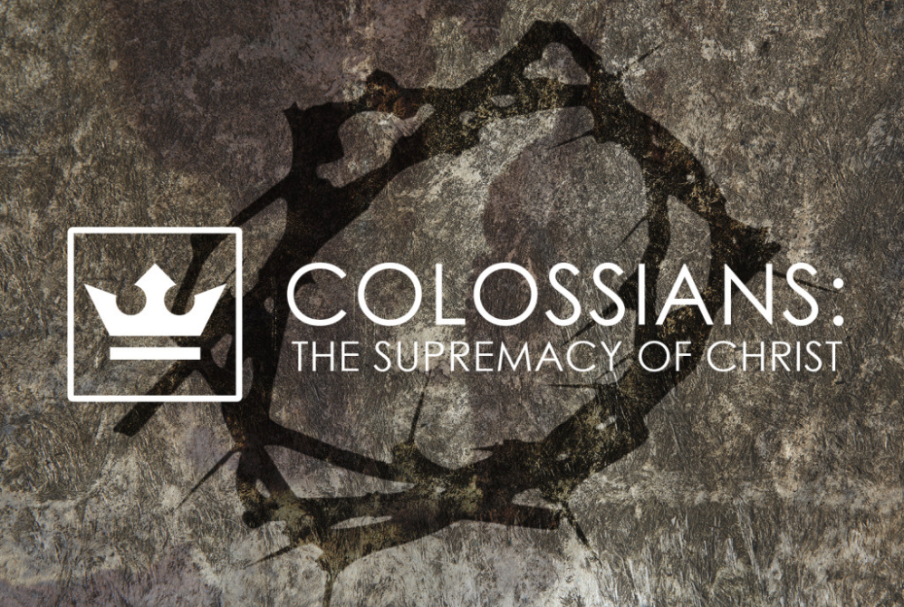
weekend
resource guide
for the week of 5 May

Then Caleb said, “We should by all means go up and take possession of it, for we will surely overcome it… But my servant Caleb, because he has had a different spirit and has followed me fully, I will bring him into the land which he entered, and his descendants will take possession of it.” (Numbers 13.30; 14.24)

I [Caleb] was forty years old when Moses the servant of the Lord sent me to spy out the land, and I brought word back to him as it was in my heart… So Moses swore on that day, saying, “Surely the land on which your foot has trodden will be an inheritance to you and to your children forever… Therefore, Hebron became the inheritance of Caleb… until this day, because he followed the Lord God of Israel fully. (Joshua 14.7, 9, & 14)

Get up and break camp…
Gather manna…
Drink miracle water drawn from a rock…
Watch a pillar of cloud…
Spend the day wandering…
Set up camp…
Watch a pillar of fire and go to sleep…

That was then… but this is now…

Reveille…
Up-an-at-em…
Consecration…
Miracle crossings…
Sun standing still…
Miracle victories…
Momentum and vision…

Something changed…
God’s people were now taking Him at His Word…

Caleb is a man who wholeheartedly “closes in” to possess God’s promised tomorrow. There is nothing casual about his desire to live faithfully. He is passionate, focused, and intentional. His vision is not constrained by the limitations of yesterday or today. He sees his opportunities from the expansive vantage point of God’s promises and confidently moves forward. But it is not Caleb’s intensity but his ardent pursuit that delivers him safely into the land of God’s promised tomorrows.

Caleb teaches us that there is a direct relationship between the pronouncement of God’s promises to us and our own personal appropriation of those promises upon our lives. God’s promises are not merely aphorisms to quote but powerful kingdom certainties to embrace and order our lives by. Tomorrow’s promises will never be realized by yesterday’s old patterns. Instead God’s promises for tomorrow challenge us to live by tomorrow’s patterns today.

While this inscription is personal it is not private. God’s promises are a catalyst for internal yet visible change as lives are reordered around the veracity and the certainty of His Word. Our lifestyle will increasingly reflect the substance of tomorrow’s promises rather than today’s uncertainties—and it will be evident for all to see.

Scripture indicates that the public reflection of your personal inscription of God’s promises will include:

- Faithfully gathering with God’s people to worship, pray, and reflect upon His Word;
- Consecrating tithes and offerings in faithful giving to Him;
- Dedicating time, energy, and creativity to loving service in Jesus Name;
- Confidently sharing the reality of God’s love and presence with those who do not recognize Him yet;
- Deliberately working for reconciliation and overcoming barriers of prejudice and hostility.

Dear ones, no one enters their “Promised Land” without change and a wholehearted pursuit of God. (And no, this does not mean you are saved by your good works. Only the observation that, with the exception of the thief on the cross, is any one saved without them?!)

Enjoy your LifeGroup!

Getting to know one another…
What is one of the most meaningful letters (texts?! Posts?!) you have received? Why was it meaningful and memorable to you?

Reading Scripture together…

Colossians 1.1-14
This letter is from Paul, chosen by the will of God to be an apostle of Christ Jesus, and from our brother Timothy.

We are writing to God’s holy people in the city of Colosse, who are faithful brothers and sisters in Christ. May God our Father give you grace and peace.

We always pray for you, and we give thanks to God, the Father of our Lord Jesus Christ. For we have heard of your faith in Christ Jesus and your love for all of God’s people, which come from your confident hope of what God has reserved for you in heaven. You have had this expectation ever since you first heard the truth of the Good News.

This same Good News that came to you is going out all over the world. It is bearing fruit everywhere by changing lives, just as it changed your lives from the day you first heard and understood the truth about God’s wonderful grace.

You learned about the Good News from Epaphras, our beloved co-worker. He is Christ’s faithful servant, and he is helping us on your behalf. He has told us about the love for others that the Holy Spirit has given you.

So we have not stopped praying for you since we first heard about you. We ask God to give you complete knowledge of his will and to give you spiritual wisdom and understanding. Then the way you live will always honor and please the Lord, and your lives will produce every kind of good fruit. All the while, you will grow as you learn to know God better and better.

We also pray that you will be strengthened with all his glorious power so you will have all the endurance and patience you need. May you be filled with joy, always thanking the Father. He has enabled you to share in the inheritance that belongs to his people, who live in the light. For he has rescued us from the kingdom of darkness and transferred us into the Kingdom of his dear Son, who purchased our freedom and forgave our sins.
What? (does the Bible say?)

What is significant about the way Paul described himself?

What is significant about the way Paul addressed the recipients of this letter?

What is Paul thankful for?

Most non-Christians do not completely deny Jesus; they DO completely dethrone Him so that He no longer is unique and supreme. How does Paul refute this incorrect understanding?

What are the components of saving faith as described by Paul in Colossians 1?

How are faith, love, and hope related? How do these things work together in your own life?

What is the “good news” and how does it change lives? (1.6) Is it changing your life? Why or why not?

How does one walk in a “manner worthy of the Lord”? (1.10)

Paul’s writing clearly indicates that we cannot separate spiritual knowledge and Christian service from character. What areas, relationships, or circumstances are you tempted to do so? Why?
So what? (how will I think?)
Now what? (what difference does it make?)

What are some tangible ways you and your LifeGroup can express your gratitude to Christ? To others?

Read Paul’s prayer (1.9-12). What did Paul focus on when he prayed for the Colossian believers? How might you use Paul’s example to cultivate your own prayers?

What steps can you take to build and cultivate a solid foundation in Jesus Christ?

What people, resources or action-steps have you found helpful in building a “firm foundation” in Christ that you might recommend to your LifeGroup?

Is there one in particular that God might be calling you to revisit? If so, why?

In what areas or your life or relationships would you like God to give you strength?

