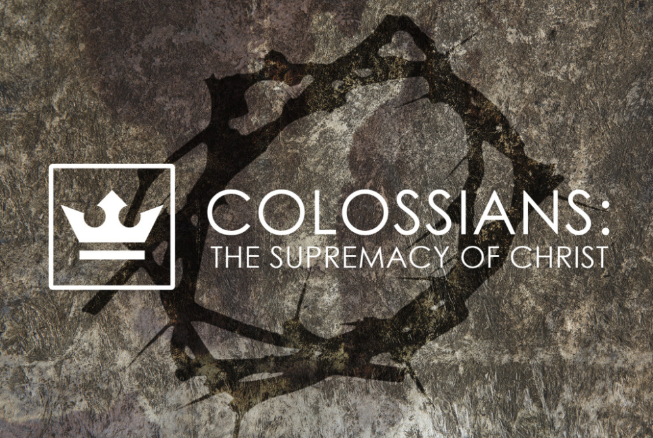
weekend
resource guide
for the week of 12 May

Truth is stranger than fiction and sometimes it is also more wonderful too. And for those who have ears to hear, truth will be a more compelling mentor than fable…

Now it came to pass when all the kings who were beyond the Jordan, in the hill country and in the lowland and on all the coast of the Great Sea toward Lebanon heard of the destruction of Jericho and Ai, they gathered themselves together with one accord to fight with Joshua and with Israel… (Joshua 9.1-2)

The cause of Israel’s joy inspired terror among the kings of the land. An advancing army of unconquerable strength threatened their sovereignty. They had heard the reports: Pharaoh, Jericho, and Ai had all given way before their advance. Therefore in desperation these kings sought an alliance whose combined strength might prove successful against their common enemy. Together they hoped to recruit Gibeon—one of the greatest cities of their region—but little did they know that Gibeon had devised a different tactic to ensure their survival: “When the inhabitants of Gibeon heard what Joshua had done to Jericho and to Ai, 4 they also acted craftily and set out as envoys, and took worn-out sacks on their donkeys, and wineskins, worn-out and torn and mended, 5 and worn-out and patched sandals on their feet, and worn-out clothes on themselves; and all the bread of their provision was dry and had become crumbled.” (Joshua 9.3-5)

At first Joshua and the elders were cautious as they remembered God’s command to conquer and cleanse the land. Therefore their initial response was to question the integrity of the Gibeonites,

“Perhaps you are living within our land; how then shall we make a covenant with you?” (Joshua 9.7).

But these “ambassadors” looked the part! Their performance and costuming were worthy of an Oscar as they professed, with a studied pathos designed to evoke pity. They claimed to have journeyed a great distance when in fact they had actually traveled less than 10 miles! Their ruse was persuasive… Joshua and the elders established a covenant with the Gibeonites and “did not ask the counsel of the Lord” (Joshua 9.14).

Three days later the Israelite army marched on Gibeon and were chagrined (to say the least) when they realized that the Gibeonites possessed a binding covenant with Israel that Joshua and the elders had previously agreed to. Joshua honored the agreement but declared: “You shall become woodcutters and water carriers for the maintenance of the Tabernacle.” (Joshua 9.23) Thus, it came to pass by this agreement that the Gibeonites and their descendants were to become accessories to the continuing worship of the Lord…

Let us pause here for an important lesson…

Scripture is clear: Joshua blundered when he did not seek the counsel of the Lord. Yet we can learn from his example that we might gain a compelling insight into how we deal with our blunders and failures. Here we witness Joshua taking the fruit of his failure and turned it toward the Tabernacle. He linked his failure with his worship by (literally) bringing it into God’s presence and subjecting it to His Lordship rather than trying to manage it on his own. When we do this it forces us to face the reality of our failure to consult the Lord as we stand before Him. It also forces us to handle with integrity the consequences of our blunders.

Dear ones, who among us has not made decisions based on reason alone without the aid of spiritual discernment? Who among us has not made decisions that have turned out to be failures that carry real consequences? What seemed obvious at the time (the people, numbers, and circumstances seemed so clear) now is a visible failure. Where you go when you recognize failure and how you conduct yourself through the morass of unintended (yet inexcusable) consequences may be a defining moment in your life as it was in the life and leadership of Joshua.

Most of us will not possess our tomorrows free of sin and failure. But the one who hides his/her failures from God is doomed to live with yesterday’s restrictions rather than with tomorrow’s liberty. This week we see where we go with our failures, next week we shall learn how to live with them…
Enjoy your LifeGroup!

Who did you think was the “Greatest” person who had ever lived when you were growing up — besides Jesus? 😉 Why?
Getting to know one another…

Reading Scripture together…

Colossians 1.15-29
He is the image of the invisible God,
the firstborn of all creation.
16 For by Him all things were created, both in the heavens and on earth,
visible and invisible,
whether thrones or dominions or rulers or authorities
all things have been created through Him and for Him.
17 He is before all things,
and in Him all things hold together. 1
8 He is also head of the body, the church;
and He is the beginning, the firstborn from the dead,
so that He Himself will come to have first place in everything.
19 For it was the Father’s good pleasure for all the fullness to dwell in Him,
20 and through Him to reconcile all things to Himself,
having made peace through the blood of His cross;
through Him, I say, whether things on earth or things in heaven.

Col. 1:21 And although you were formerly alienated and hostile in mind, engaged in evil deeds, 22 yet He has now reconciled you in His fleshly body through death, in order to present you before Him holy and blameless and beyond reproach — 23 if indeed you continue in the faith firmly established and steadfast, and not moved away from the hope of the gospel that you have heard, which was proclaimed in all creation under heaven, and of which I, Paul, was made a minister.

Col. 1:24 Now I rejoice in my sufferings for your sake, and in my flesh I do my share on behalf of His body, which is the church, in filling up what is lacking in Christ’s afflictions. 25 Of this church I was made a minister according to the stewardship from God bestowed on me for your benefit, so that I might fully carry out the preaching of the word of God, 26 that is, the mystery which has been hidden from the past ages and generations, but has now been manifested to His saints, 27 to whom God willed to make known what is the riches of the glory of this mystery among the Gentiles, which is Christ in you, the hope of glory. 28 We proclaim Him, admonishing every man and teaching every man with all wisdom, so that we may present every man complete in Christ. 29 For this purpose also I labor, striving according to His power, which mightily works within me.
What? (does the Bible say?)

NOTE: This passage is actually a poem, one of the very earliest Christian poems ever written. Paul wrote it (or, if the poem was originally written by someone else, quoted it) to show the Colossians the center of Christianity. It isn’t simply about a particular way of being religious. It isn’t about a particular system for how to be saved here or hereafter. It isn’t simply a different way of holiness. Christianity is about Jesus Christ. If we are to grow as Christians, increasing in wisdom, power, patience and thanksgiving, we need to know above all what the Colossians needed to know: the centrality and supremacy of Jesus Christ.

What is the source of Paul’s joy? How does this square with your understanding of the Christian life?

What does it mean for Paul’s sufferings to “fill up what is lacking in Christ’s afflictions”?

What is the “mystery” Paul refers to twice in vs 26-27? Where and how has it been revealed?

What, in your own words, is Paul’s life-long ambition summarized in vs 28-29?

So what? (how will I think?)

Jesus Christ is the one through whom and for whom the whole creation was made in the first place. When awe-inspiring beauty of the world causes you to catch your breath, remember this beauty is because of Jesus. The One through Whom and for Whom the world was made is the same Jesus through Whom the world has now been redeemed. He is the firstborn of all creation and the firstborn from the dead.

What are the “titles” used to describe Jesus in vs 15-20? Define each title you identify.

How would you sum up what these verses reveal about Christ?

Do you think Paul’s description of Jesus in vs 15-20 is true? Why or why not?

If verses 15-20 is a “theological map” of the cosmos then verses 21-23 are your theological location— i.e. looking on a map that has an arrow: “You are here”. How do you respond to the truth that you are in God’s presence “holy, blameless and without any accusation” (v. 22)?

Now what? (what difference does it make?)

What are one or two ways in which your life is different since you were changed from being “alienated from God to being reconciled through Christ’s death”? (vv. 21–22)

What are the implications of the centrality and supremacy of Christ for
- family and friendships?

- your marketplace relationships?

What problems have you encountered in helping someone understand why Jesus is unique and preeminent? How might your LifeGroup encourage and resource you?

What resources can you share that encourage and equip “you continue in the faith firmly established and steadfast”? (v23)

Prayer requests…
(write in advance what you want your group to pray for…)

Praying for my group…

